Julie Snowdon - 01623 463721

jsnowdon@mansfield.gov.uk

28 July 2021

Dear Sir/Madam

**PROPOSED MANSFIELD DISTRICT COUNCIL CIVIL ENFORCEMENT OFF-STREET PARKING PLACES ORDER 2021**

Mansfield District Council is proposing to make the above Order (“the Proposed Order”) covering all off street parking places in the District of Mansfield.

I enclose a copy of the formal notice of this Council’s proposal which sets out the Proposed Parking Charges and the Proposed Penalty Charges. I also enclose a copy of the Proposed Order and a copy of the statement setting out the reasons why the Council is proposing to make the Order.

I am arranging for the notice of proposal to make the Proposed Order to be advertised in the Mansfield Chad on 28 July 2021. It is also intended for site notices to be displayed at all the car parks included in the Proposed Order to give full publicity to the proposal. In addition, a copy of the draft Proposed Order will be put on the Council’s web site at [**www.mansfield.gov.uk/offstreetparking**](http://www.mansfield.gov.uk/offstreetparking)and a copy will be available for viewing at both Civic Centre, Chesterfield Rd S, Mansfield, NG19 7BH and at Old Town Hall, Market Place, Mansfield, NG18 1HX Monday-Friday between the hours of 8 30am and 4 00pm.

The effect of the proposal will be to confirm the new proposed parking charges, protecting designated bays for specific use as electric vehicle charging bays and redefine the area of Prince Charles car park, Forest Town. The Proposed Order will also revoke all previous orders at the car park locations.

Before proceeding further with these proposals, the Council wishes to consider the views of organisations likely to be interested in this matter. Due to the large number of organisations involved, I regret it may not be practical to respond individually to your reply. However, any suggestions will be incorporated in to the proposals wherever appropriate and economically feasible. If your comments are in the form of an objection to the proposals and if they cannot be resolved, they will be reported by the Head of Neighbourhoods who will consult with the appropriate Portfolio Holder. Any comments, observations or representations on these proposals should be made in writing and reach me by 1 September 2021 otherwise, I will assume that you have no comments to make.

If you have any queries on the Proposed Order please contact Julie Snowdon, Town Centre Manager, on the above email address or by telephone.

Yours faithfully

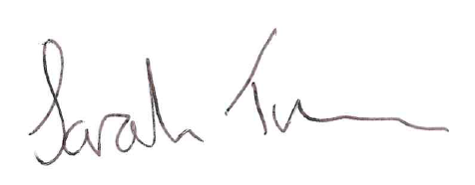

Sarah Troman

Head of Neighbourhoods