Briefing Paper
To
Overview & Scrutiny Committee (Place)
On
26th September 2023
TOWN CENTRE UPDATE

1. SUMMARY

This briefing paper gives Overview & Scrutiny Committee (Place) an update on the services provided by Town Centre Operations.

2. BACKGROUND

2.2 The areas in this paper are bullet-points for Town Centre Operations and Street Cleansing.

TOWN CENTRE

3. MARKETS

3.1 Market Income

The income for markets for the last three years is detailed in the table below and shows a year-on-year increase.

 | Apr - Jun
Year | Income | Year on Year  % change
2021/22 | £17,390 | N/A
2022/23 | £18,046 | +3.7%
2023/24 | £19,446 | +7.5%

Income has increased by 7.5% on the same period in 22/23 and has increased by 12% when compared to 21/22.

During this quarter new traders were incentivised by the Love Your Local Market ‘free month of May’ trading, as well as ongoing incentives and discounts for regular licenced traders.

The authority has also been supporting Mansfield BID’s monthly Antique & Craft market and Vegan Market which have been established to support the regular Saturday and to increase footfall to the market.

4. CAR PARKS

4.1 Car Park Income

The income for car parks for the last three years is detailed in the table below and shows a year-on-year increase.

 | Apr - Jun
Year | Income | Year on Year  % change
2021/22 | £172,981 | N/A
2022/23 | £242,608 | +40%
2023/24 | £172,123 | -29%

Income has decreased by 29% on the same period in 22/23 but has decreased by 0.5% when compared to 21/22.

5. SHOPMOBILITY

The Shopmobility service continues to operate from Walkden Street car park, with the bottom level reserved for disabled customers and parent & child whilst two of the lifts are out of operation. The income data is as detailed below:-

 | Apr - Jun
Year | Income | Year on Year  % change
2021/22 | £267 | N/A
2022/23 | £335 | +25%
2023/24 | £374 | +12%

There is a 12 % increase on the same quarter in 22/23, however, and an increase of 40% when compared to 21/22.

6. PUBLIC CONVENIENCES

The charges are not comparable from 2021/22 due to charges being removed, therefore the percentage change has been calculated by comparing 23/24 to 22/23.

 | Apr - Jun
Year | Income | Year on Year  % change
2021/22 | £0 | N/A
2022/23 | £2,429 | N/A
2023/24 | £4,127 | +70%%

There is an 70% increase on the same quarter in 22/23.

Work is currently under way to restore the current trader’s toilet to a Unisex accessible toilet for the public to use, which will be charged at 20p per user in line with Four Seasons toilets, but planning consent is required for the external signage.

Once opened the market traders will be able to use the Old Town Hall internal toilets during the normal opening hours of the building, i.e., 8.30 am to 5.00 pm.

7. FOOTFALL

Please see Appendix 1 attached for the footfall information for this quarter.

Footfall was higher by 159% in this quarter when compared to the same period in 2022/23 and by 24% compared to 21/22.

This is a positive for the town centre, businesses, and visitors, whilst providing critical data for any new potential investors.

Partners such as the Four Seasons Shopping Centre are also seeing an increase in both footfall and new business start-ups.

8. URBAN GREENING PROJECT

- Memorial Garden is now complete and was officially opened on the 1st August.

- Walkden Street pocket park - works are complete and the site is open.
- Quaker Way – this area is completed, however there will be some additional bulb planting in the next two months to enhance the current planting scheme.
- Walkden Street concourse – waterproofing and resurfacing works complete. Fixing plates installed ready for benches to be installed, litter bins installed, and trees ordered for delivery in October.
9. EVENTS

The town centre team have provided operational support both internal and external events across this period to ensure the events operate efficiently and safely to encourage footfall and dwell time into the district.

The electrical team are also busy planning and applying for the licences for this years Christmas lights.

10. STAFFING

There is currently one vacancy in the frontline teams, which is temporarily being covered by an agency post. There are some difficulties within the management team, due to both supervisors on restricted duties at the moment for different reasons and the manager continuing to support Waste & Recycling during this period.

11. COMMENTS OF HEAD OF SERVICE

11.1 The completion of the memorial garden has been a huge achievement and several positive comments have been received from the public about the new space already. The team are fully engaged in activities with partners and other teams including clean ups and Christmas Switch On and continue to deliver a great service.

STREET CLEANSING

12.1 STAFFING

There are still some vacancies within the service, however, two successful appointments have been made, one beat sweeper in the town centre and one into the spare pool, to cover for holidays, sickness, and vacancies.

All vacant posts are currently being reviewed prior to advertising to ensure they are fit for purpose for the service to operate efficiently.

In the interim services are being prioritised with staffing allocated to critical services i.e., mechanical sweepers, litter bins, high frequency routes etc. to ensure continuity of service provision in the areas of greatest need.

The team are fully operational now with the Whitespace system which is starting to provide valuable data on performance, demand and frequencies which will inform future service re-design.

12.2 STREET CLEANSING DATA
The table below shows the total street cleansing waste collected and tonnage of fly tipping collected.
Tonnage of Street Cleansing Waste
2023-2024
 | Qtr 1 | Qtr 2 | Qtr 3 | Qtr 4 | YTD
Total street cleansing waste (excluding fly tipping) | 379.17 |  |  |  | 379.17
Fly Tipping tonnage collected | 49.85 |  |  |  | 49.85
Grand Total | 429.02 |  |  |  | 429.02

The street cleansing tonnage (mechanical and street cleansing waste exc. fly tipping) for Qtr 1 - 23/24 is 429.02 compared to 263.62 in 22/23 that’s an increase of 63%.
Two new mechanical sweepers have arrived which has increased overall performance of the service as the old sweepers were affecting the quality and had an inc. breakdown rate of those machines.
Staff are still being encouraged to report all pot holes to NCC on their online portal to ensure that they are repaired as quickly as possible
12.3 FLY TIPPING DATA

The table below shows the quarterly breakdown of fly-tipping incidents attended to and the removal costs.

Fly Tipping

 | No. of incidents | Cost £
2023/24
Qtr 1 | 506 | 23,549
Qtr 2
Qtr 3
Qtr 4
Total | 506 | 23,549
2022/23
Qtr 1 | 450 | 21,500
Qtr 2 | 512 | 23,296
Qtr 3 | 559 | 27,067
Qtr 4 | 612 | 27,191
Total | 2133 | 99,054

In comparison to the previous year, the incident data shows an increase of 12% during Qtr. 1 compared to the same period last year.

A detailed breakdown of the incidents and costs is at Appendix 2. This also summarises the actions, including any fixed penalty notices issued by the Neighbourhood Wardens.

12.4 STREET CLEANLINESS

The reorganisation of staffing and prioritisation of services has led to an improvement in the overall cleanliness of the district as show in the chart below. The % of relevant land meeting the acceptable level of cleanliness for litter and detritus was 86% for 23/24 compared to 71% in the same period in 22/23.
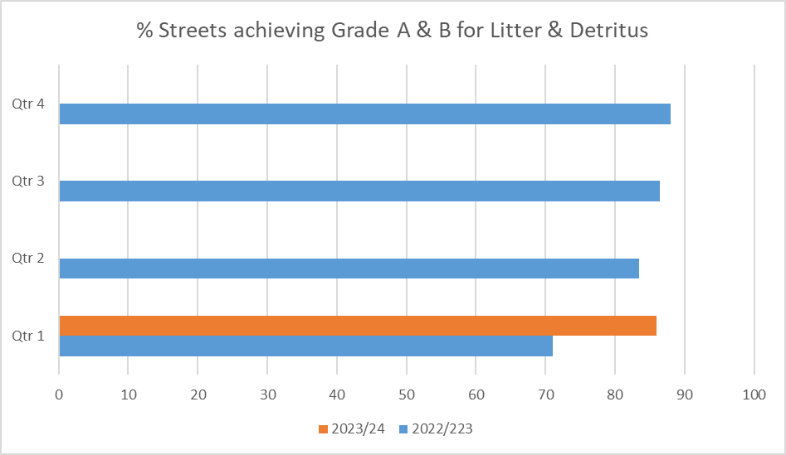

The current condition of the highways and significant number of potholes continues to be challenging for the service due to the amount of detritus in the form of gravel that the sweepers are picking up.

12.5 SAFER STREETS 4

The service continues to support the Safer Streets 4 project in Warsop with the following actions:-

- Targeted graffiti removal
- Enhanced mechanical sweeping
- Targeted manual cleansing of key areas
- Days of action to provide a high visible presence of service on specific days
- Installation of new litter bins

This work is ongoing, and the service will continue to work with partners to support the project.

13. STAFFING

13.1 Currently there are 4 members of staff absent due to long term sickness and 2.5 x Driver Cleansing Operatives (spare pool) vacant.

The implementation of Whitespace has enabled staff to record accurate data sets for their areas of work which will enable more efficient and effective service delivery in future once sufficient data has been gathered.

14. COMMENTS OF HEAD OF SERVICE

14.1 The reorganisation of Street Cleansing has already demonstrated a shift in cleanliness scores, which is a very positive step. The team have coped with the roll out of Whitespace very well, which will enable further development and improvements to be made within the service.

Report Author | - | Julie Snowdon
Designation | - | Town Centre & Street Cleansing Manager
Telephone | - | 01623 463721
E-mail | - | jsnowdon@mansfield.gov.uk

Appendix 2

Breakdown of Fly-tipping Incidents & Costs

April to June 2023

Breakdown of Actions & Costs Relating to Fly-Tipping Incidents
April to June 2023
(Supplied by Neighbourhood Wardens)

